LPO 7870 Research Design and Data Analysis II, 2024
Assignment 4

Submission Guidelines:
- Please submit an electronic copy of your group’s solutions as a PDF file by 4:00 pm, Monday, April 8.
- All submissions via Brightspace in the “Assignments” section —only one submission per group.
- Please include the Stata output (you can copy and paste the main Stata outcomes).
- Pro-tip: if you use Courier New font, Stata output will line up as it does in the output window.

Question 1. Linear Probability Model. (24 points)

The Stata dataset nhes_2019_extract.dta (posted on Brightspace and Github) was derived from the 2019 administration of the National Household Education Survey (NHES) conducted by the National Center for Education Statistics. The variables in this dataset pertain to a focal child in the household as well as the child’s parents or caregivers. For example, there are questions about the type of school the child attends (public, private, charter, homeschool), their grade level, their disability status, etc. (The variables in this extract are only a small subset of all the variables available).

- The variable homeschool equals 1 if the student is homeschooled and 0 otherwise. What proportion of students in this sample were homeschooled? (2 points)

- In Stata, estimate a linear probability model where homeschool is the dependent variable and age (age2018) is the sole explanatory variable. Show your resulting output. (5 points)

  - Carefully interpret the slope coefficient on age.
  - Is this coefficient estimate statistically significant? Explain how you know.

- Consider two students, one aged 6 (1st grade) and the other aged 12 (7th grade). Based on your results in part (b), how much more or less likely is the older student to be homeschooled? (4 points)

- Now add additional explanatory variables to the linear probability model in (b): child’s race or ethnicity (raceeth), student has a disability (swd), parent’s highest level of education (pargradex), number of siblings (numsibsx), and household internet access (intacc2). Note that raceeth and pargradex are categorical variables; we recommend using the “i.” prefix with these variables so that Stata treats them as such. (5 points)

  - Show your resulting output, and comment on how each of these variables is related to students’ likelihood of being homeschooled.
  - Which explanatory variables are statistically significant?

- Consider a 12-year-old White student without a disability, whose highest-educated parent had a college degree, with 2 siblings and internet access at home. Based on your results in part (d), what is the predicted probably this child is homeschooled? (4 points)

- Use Stata’s predict command to obtain predicted probabilities of being homeschooled for every student in the dataset. (4 points)

  - Are there any predicted probabilities below 0 or above 1? If so, how many?
  - What alternative approach might you use in the event predictions fall below 0 or exceed 1?

Question 2. Randomized controlled trial in Kenya. (28 points)

In an early impact evaluation in a low-income country, Glewwe, Kremer, and Moulin (2009) tested the hypothesis that poor school performance was due to a lack of textbooks. At that time, a significant portion of education system resources was already allocated to textbook purchases. Partnering with an NGO that donated the books, adhering to the country's official curriculum, the research team conducted a randomized controlled trial (RCT) in rural Kenya across 100 public schools. These schools were randomly divided into four groups of 25 each. The first group received textbooks in the first year, the second group in the second year, and so on. Data collection occurred at baseline (t=0), after one year (t=1), and after two years (t=2) of the intervention. The team tested both students who received textbooks and those who did not during all three time periods.

The simplified version of their regression model is as follows:

$$S_{t}=β_{0}+β_{1}T_{t}+β_{2}X_{2,0}+…+β_{k}X_{k,0}+μ_{t}$$

where $S_{t}$ is a student’s score at time t, $T$ is the indicator of treatment (1 if the school received textbooks, 0 if not), and $X_{2,0}…X_{k,0}$ are a set of control variables at time t = 0 such as the gender of the student, age, etc.

- What would you expect to see in your data if the randomization was successful? (2 points)

- How would you test whether or not the randomization was successful? (3 points)

The main results are presented in Table 1 below (adapted from Table 4 of the original paper).

Table 1.
Dependent Variable: | Test score (S) | Test score (S)
 | First year | Second year
Treatment (T) | 0.023 | 0.020
 | (0.870) | (0.104)
Number of schools treated | 25 | 50
Number of schools control | 75 | 50
Number of students | 24,132 | 12,663
Note: This table is based on Glewwe et al 2009. Standard errors are in parenthesis

- Based on the results of Table 1, what is the effect of the program on student learning? (3 points)

- One researcher argues the following: “These results are not credible since $E(u|T)$ is not equal to zero.” Do you agree with this researcher, or not? Please discuss. (3 points)

(The following numbers about attrition were created for the purpose of this question and are not found in the paper). Another researcher points out that the attrition rate in the study is problematic. At baseline, there were 27,910 individuals, with 6,798 in the treatment group and 20,932 in the control group. In contrast, at the first follow-up, the total was 24,132, with 5,861 in the treatment group and 15,071 in the control group.

- Please describe the problem of attrition generally and why it is problematic for an RCT (4 points).

- In this case, what is the overall attrition rate in the first year? What is the attrition rate for the treatment group, and what is the attrition rate for the control group? What are the potential implications of these rates? (4 points)

Glewwe et al. were interested in the effects of the intervention on students based on their baseline performance. The hypothesis was that students who were better prepared at baseline would benefit more from the textbooks. To test this, they created a variable (called "Pretest") that was set to one for all students above the mean baseline test score and to zero for all others. They then estimated the following regression:

$$S_{t}=β_{0}+β_{1}T_{t}+β_{2}{Pretest}_{0}+β_{3}{Pretest}_{0} X T_{t}+μ_{t}$$

${Pretest}_{0} X T_{t}$ is the interaction between the Pretest (at baseline) and treatment. Assume that the authors did not control for any other variables in this model. The results are in Table 2 below:
Table 2.
Dependent Variable | Test score (S) | Test score (S)
 | First year | Second year
Treatment (T) | 0.060 | -0.016
 | (0.061) | (0.088)
Pretest score | 0.430 | 0.342
 | (0.013) | (0.016)
Pretest score X Treatment | 0.057 | 0.061
 | (0.018) | (0.022)
Number of schools treated | 25 | 50
Number of schools control | 75 | 50
Number of students | 11,342 | 7,393
Note: This table is based on Glewwe et al 2009. Standard errors in parenthesis

- Based on these results in Table 2, what is the effect of the textbook program on students with pretest scores below the mean? Please discuss using the estimated coefficients and standard errors presented above. (3 points)

- Based on the results in Table 2, what is the effect of the textbook program on students with pretest scores above the mean? Please discuss using the estimated coefficients and standard errors presented above. (3 points)
- A researcher criticizes the results, arguing that the model would not provide unbiased estimators of the textbook effect since the authors do not control for other characteristics. Do you agree with this researcher or not? Please discuss. (3 points)

Question 3. Linear probability model in Ladd (2011) (10 points)

The article by Ladd (2011) on the class syllabus uses data from North Carolina to identify factors related to teachers and their perceptions of working conditions that predict planned and actual turnover. An excerpt from Table 8 in that paper is shown below. This table shows the estimated coefficients and standard errors from a linear probability model where the dependent variable equals one if the teacher left their position at the end of the year and zero otherwise.

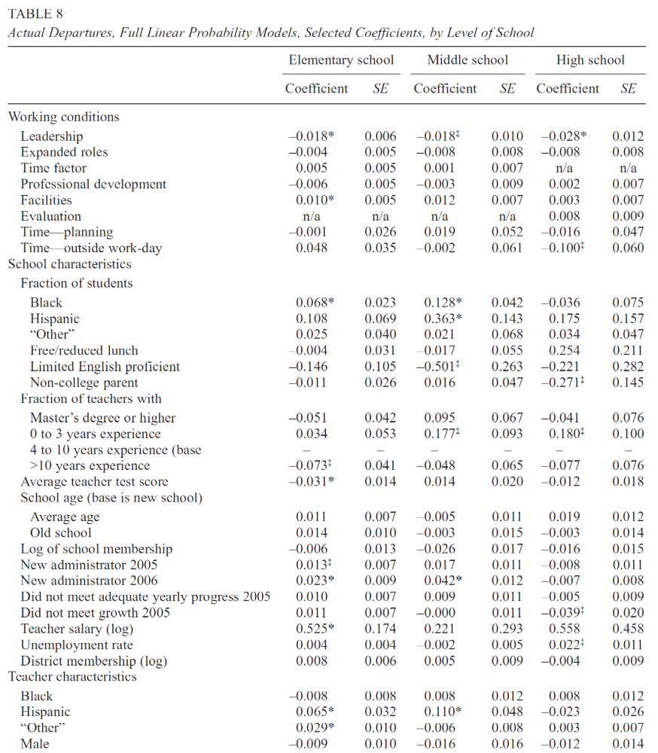

- Provide a written interpretation of the estimated coefficients for Working conditions: Leadership, separately for elementary, middle, and high school. Please note that the working conditions variables are standardized indices (z-scores) with a mean of 0 and a standard deviation of 1. Are these coefficients statistically significant? (6 points)

- Provide a written interpretation of the estimated coefficient for Teacher salary (log), separately for elementary, middle, and high school. Please note that this variable is measured using a natural log. (4 points)

